Figure 6. Photomicrographs (phase contrast and and ordinary illumination) of various photosynthetic bacteria (Norbert Pfennig). Magnifications are about X1400. The purple and green bacteria exhibit a full range of prokaryotic morphologies, as these photomicrographs illustrate.
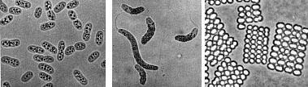
A. Purple sulfur bacteria (L to R): Chromatium vinosum, Thiospirillum jenense, Thiopedia rosea
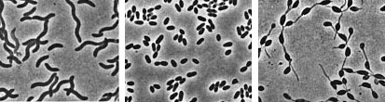
B. Purple nonsulfur bacteria (L to R): Rhodospirillum rubrum, Rhodobacter sphaeroides, Rhodomicrobium vannielii
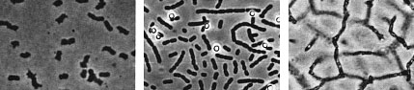
C. Green sulfur bacteria (L to R): Chlorobium limicola, Prosthecochloris aestuarii, Pelodictyon clathratiforme
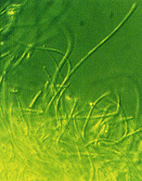
Figure 7. Green nonsulfur bacterium, Chloroflexus (T.D. Brock). Chloroflexus represents a phylogenetically distinct group of green bacteria, which includes other green nonsulfur bacteria. Chloroflexus is a thermophilic, filamentous gliding bacterium.
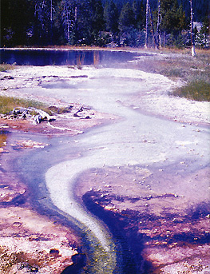
Figure

